SILo: Sistem Informasi Logistik

Use Case Specification: View Invoices

Version 1.0

Revision History

|  |  |  |  |
| --- | --- | --- | --- |
| **Date** | **Version** | **Description** | **Author** |
| 01 Okt 2020 | 1.0 | Initiation | Daniel Siahaan |
|  |  |  |  |
|  |  |  |  |
|  |  |  |  |

Table of Contents

1. Insert Metadata 4

1.1 Brief Description 4

2. Flow of Events 4

2.1 Basic Flow 4

2.2 Alternative Flows 4

2.3 Exceptions 4

3. Special Requirements 4

4. Pre-Conditions 4

5. Post-Conditions 4

6. Extension Points 5

Use Case Specification: View Invoices

# Insert Metadata

## Brief Description

This use case describes how the warehouse view the list of invoices. After viewing the list, the warehouse can manage each invoice.

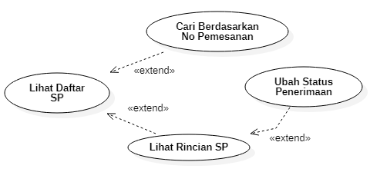

# Flow of Events

## Basic Flow

1. In the main page, Warehouse clicks **Invoices** menu.

2. The system shows the list of invoices.

## Alternative Flows

n.a.

## Exceptions

2b.2a.1a If there is one or more item unavailable, the invoice accepting is canceled.

2b.2a.1a.1 The warehouse clicks on Pending button.

2b.2a.1a.2 The system changes the status to ‘pending’.

# Special Requirements

1. Only authorized and authenticated warehouse may change the status of invoice.
2. The list of invoices should display at least the following information: invoice number, po number, supplier name, order date, delivery date, and status.

# Pre-Conditions

1. A new invoice should have a ‘new’ status.

# Post-Conditions

1. The delivery date of a completed invoice should be set to current date.

# Extension Points

2a The warehouse can **Search Invoice** to find invoices that matched specific invoice number.

2a.1 The warehouse fills the keywords, then clicks the **Search** button.

2a.2 The system shows the list of matched invoices.

2b The warehouse can **View Invoice Description**

2b.1 The warehouse clicks on **View** button of corresponding invoice.

2b.2 The system shows the description of the invoice.

2b.2a The warehouse **Change Invoice Status** after checking the condition of the delivered items and their compliance to the invoice.

2b.2a.1 The warehouse clicks **Accept** buton.

2b.2a.2. The system changes the status of the invoice to ‘completed’